**S3D Printer Instructions**

**Insert your file:**

- S3D printer comes with its own Micro SD memory card, user must use the printer's memory card to print

- SD card is located in the card slot on the side of the machine

* Note：

- There are firmwares in the SD card, so DO NOT delete any file from the SD card

- Please use the card reader when copying files to the SD card

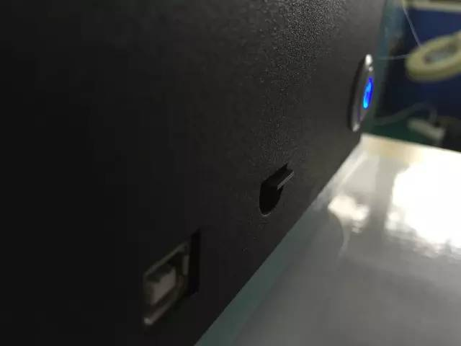S3D SD Card location

- In Cura, slice your *.stl file into the *.gcode file.

- Save the *.gcode file in S3D SD card, and insert the card into the machine.

- Turn on the machine and check if the parameters are within normal range:

X, Y, Z should all be 0.000, and there should be a temperature display (e.g. "T: 149.1/210")

**Calibration of the bed:**

- Press "Control" on the screen and click x home, y home and z home.

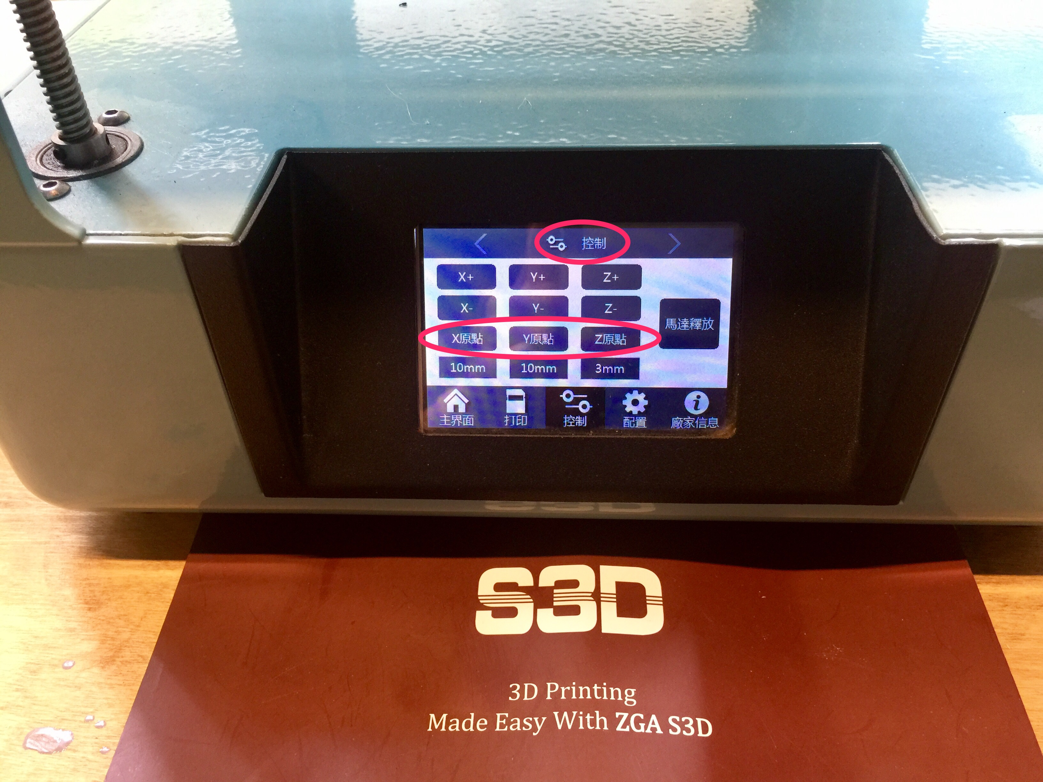

- Press "Main" on the screen and choose "Calibration".

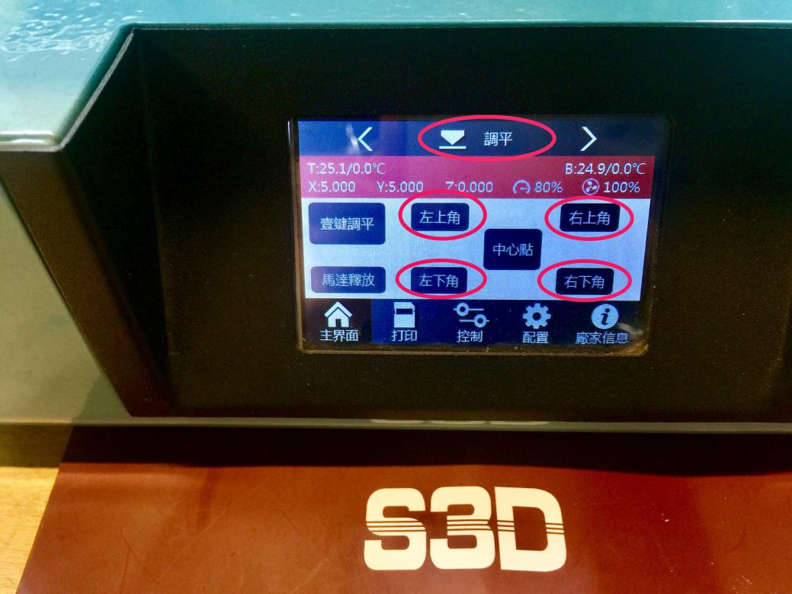

- Click on the top left corner and put a piece of A4 paper between the nozzle and the bed.

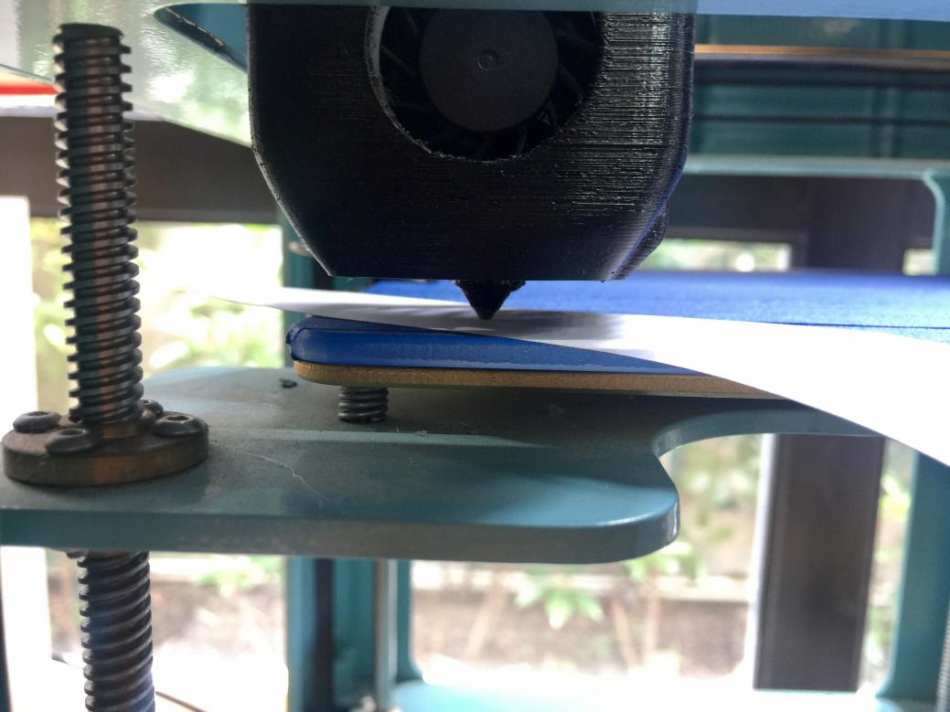

- Adjust the top left screw to tighten or loosen the paper, until it has a perfect feel of friction.

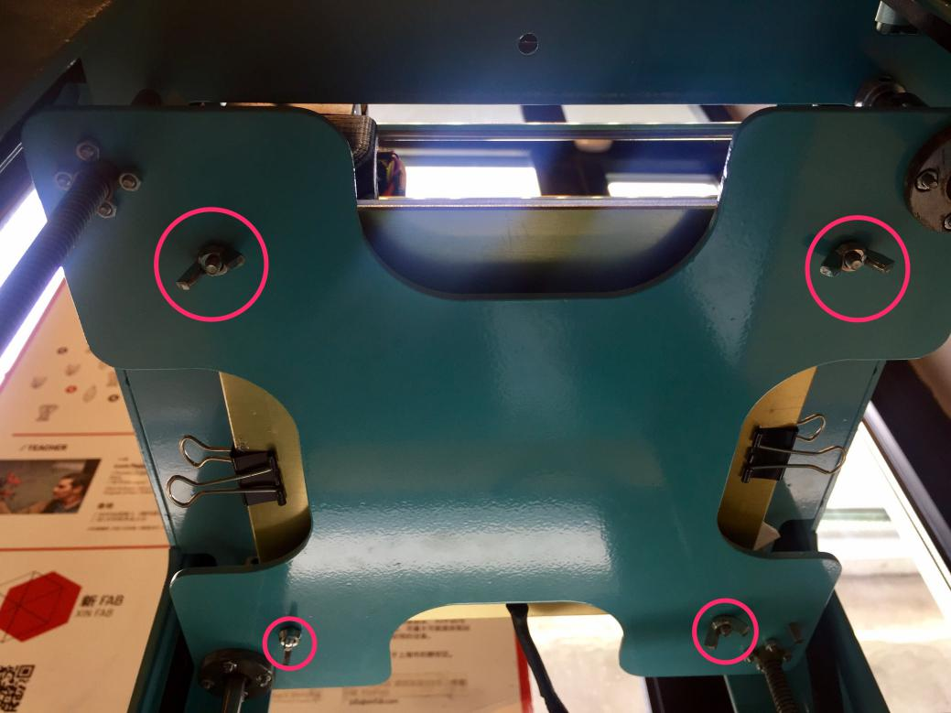

- Repeat the process to check the rest corners and make sure the bed is flat.

**Start to Print:**

Click on the right arrow on the top bar to go to the "preheat" page, choose "PLA", wait till the temperature reacheas 210C.

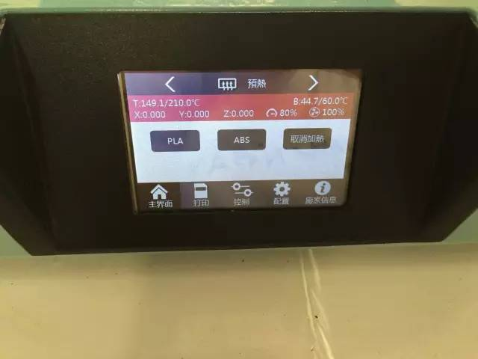

"Preheat" page

- Choose "Print" from the bottom tool bar

- If no documents load, click on the three-line icon on the right

- Choose your file to print, click on "OK"

- Click on "Start"

**Remove the model:**

- After printing is finished, wait till for the printed model to chill

- Remove the binders on the side of the printing platform

- Remove the printing platform, tilt the platform, use the shovel to scoop up the edge of the model, tap on the bottom of the shovel to remove the model

- Return the platform to its original position

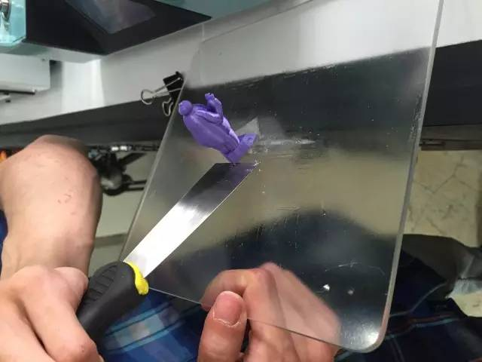How to remove the model from the printing platform

**Change the Filament**

- Choose "PLA" in the "Preheat" page

- Wait till the temperature reaches 210C, then push the material down the extruder, till you can observe the normal discharge from the extruder

- Now, hold down the spring on the left and the pull out the material quickly.

- Trim the new material to have a clean cut edge at the one end

- Hold down the spring again and insert the new material into the extruder

- Push the material till you observe normal discharge from the extruder

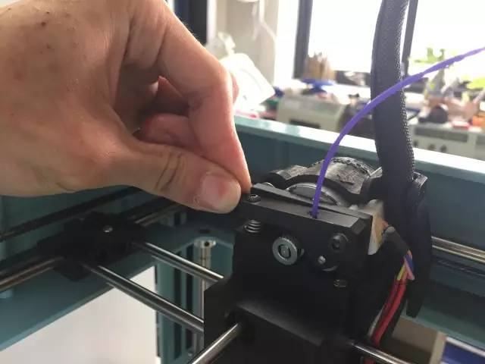Hold down the spring switch

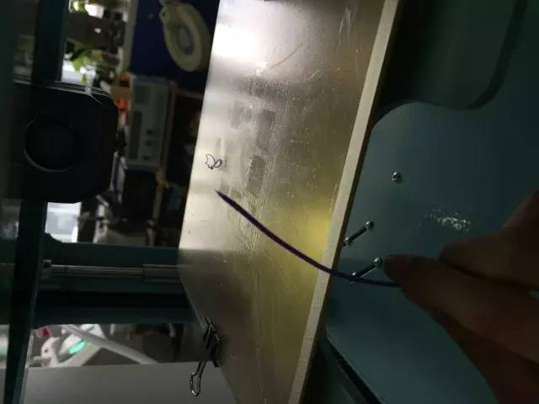Pulling out the material

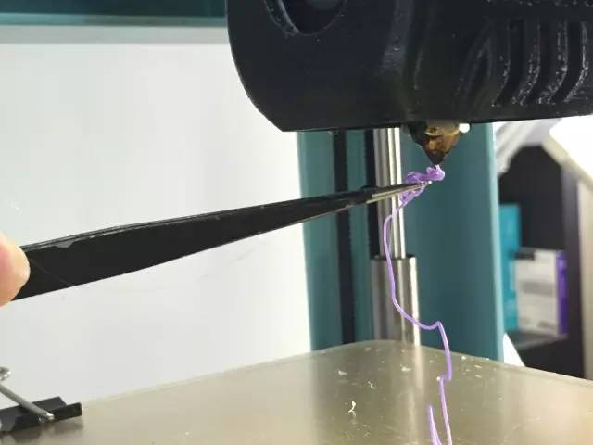Please use the tweezer when remove the extra material

* Note：

- If the discharge is too thin, then it means the extruder is blocked

- If there are tiny black substance mixed in the discharge, then it means the extruder needs cleaning

- In case the two aboved scenarios do not occur but you still experience difficulty in pushing the material into the extruder, call the space manager to the rescue!!!!!!